📋 PROJECT PROGRESS REPORT

To: Principal Ma'am (Patliputra Vidyapeeth)
From: Sumit Sahay (Web Development Lead)
Date: June 27, 2026
Subject: Status Update – Patliputra Vidyapeeth Official Web Portal

Overview
The core development phase of our school web portal has been successfully completed. The entire web architecture is built completely on an in-house local infrastructure (no-cloud reliance), ensuring that all school data remains 100% secure, private, and under our absolute local control.

Latest Updates & Key Features Implemented
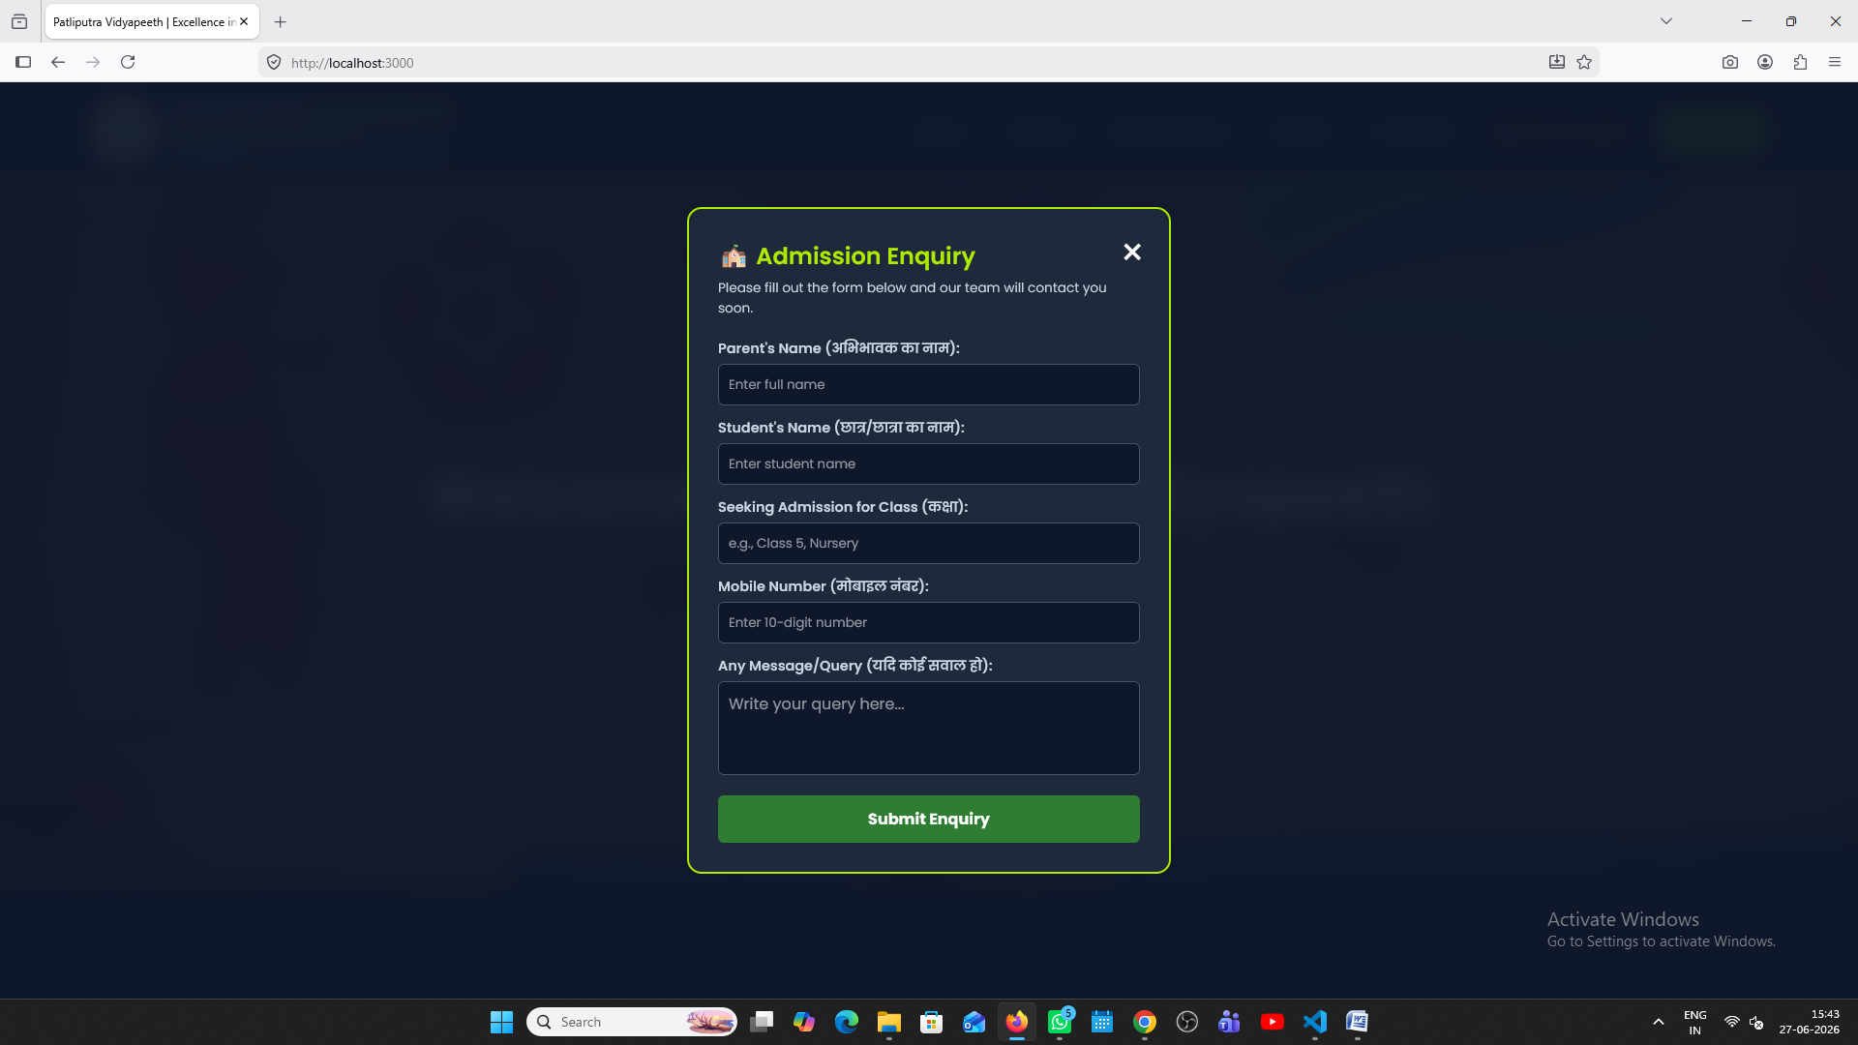
- Dynamic Admission Enquiry System: The 'Enquiry' button on the main website's navigation header is now fully live. When parents submit the admission query form, their details (Parent's Name, Student's Name, Target Class, Mobile Number, and Message) are recorded directly into our secure local database with an automatic date and time stamp, entirely bypassing external cloud networks.

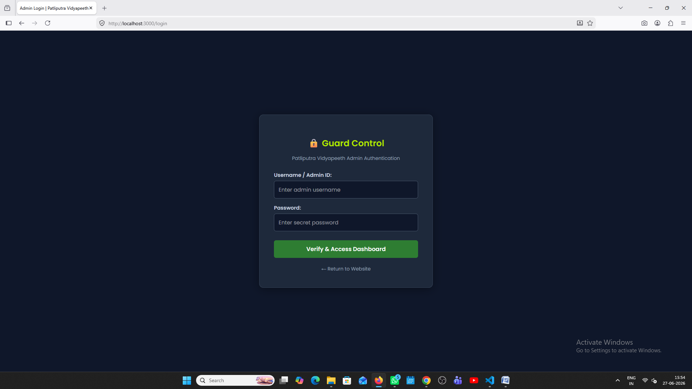
- Live Control Admin Dashboard: The admin management panel has received a major upgrade. A dedicated 'Live Explorer & Submissions' section has been integrated onto the right side of the dashboard. This enables the administration to monitor all real-time parent enquiries, active notice board circulars, and published gallery albums from a single screen.
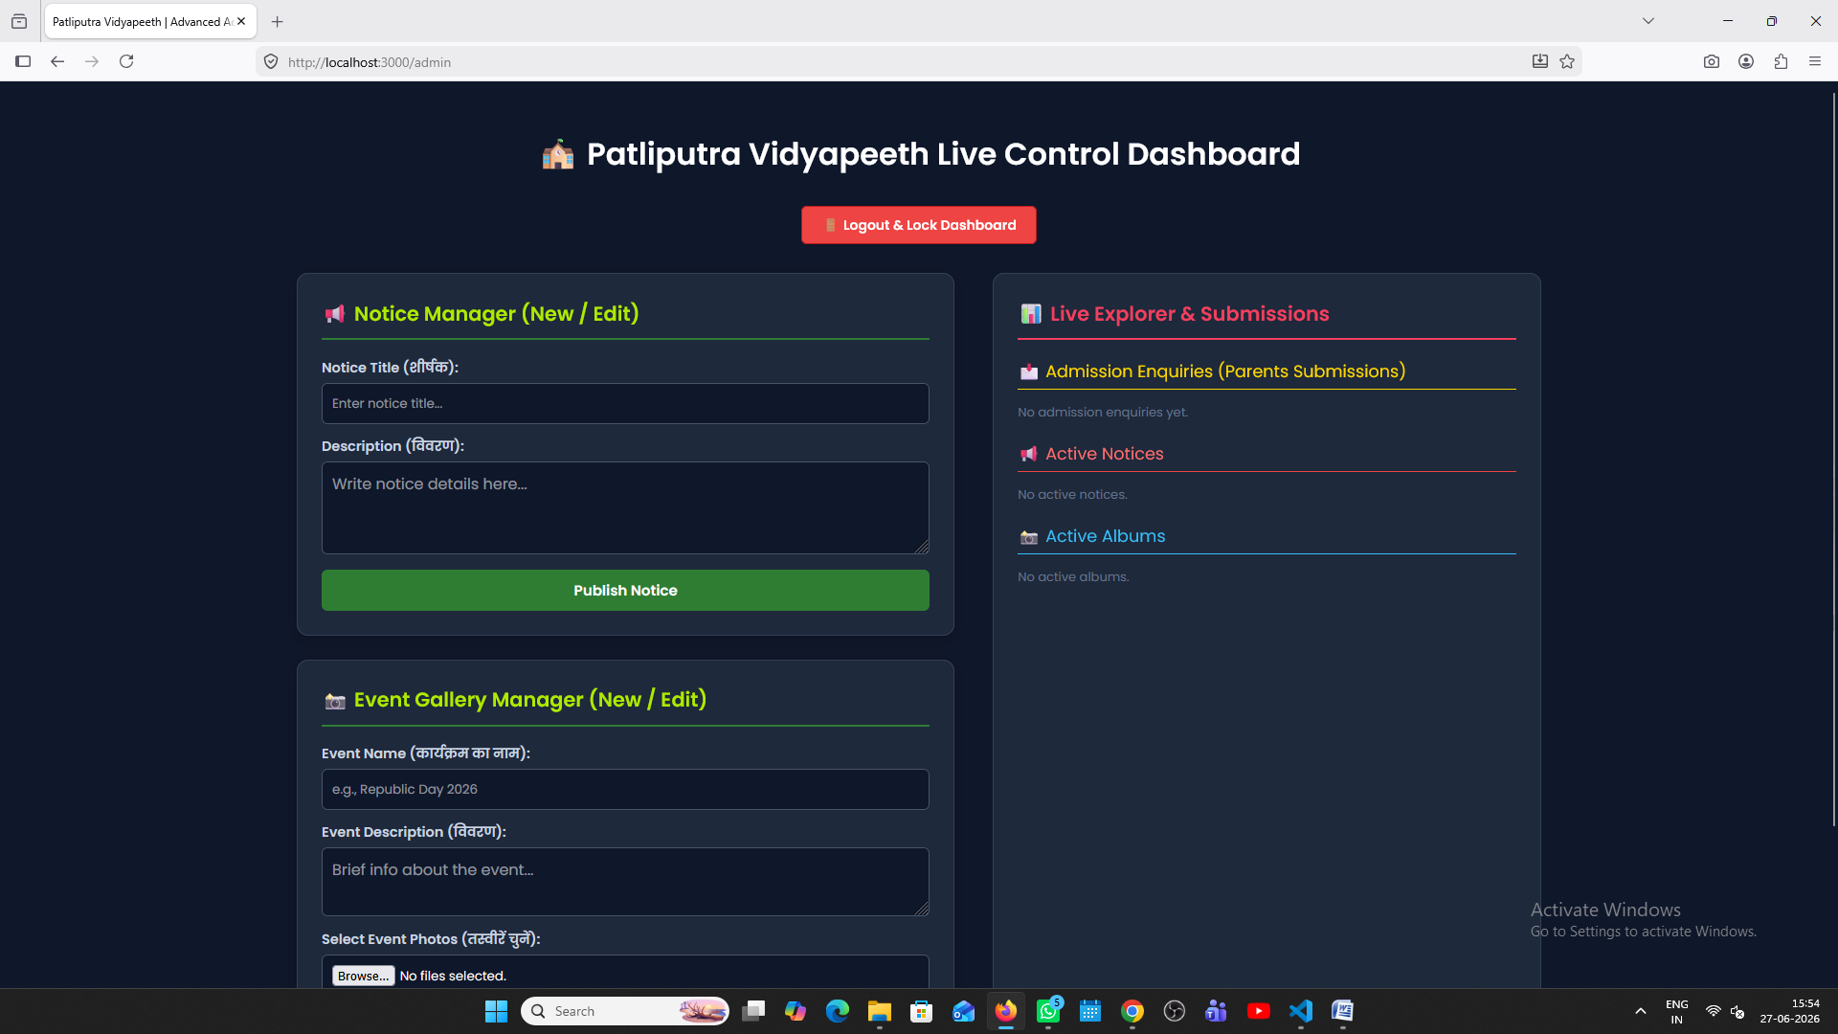

- Smart Storage Management (Auto-Cleanup Logics): To optimize system performance, the backend now coordinates automated file cleanup. When an unwanted notice or a photo event album is cleared or deleted from the admin panel dashboard, our server code automatically deletes those specific image files permanently from the computer's hard drive storage, preventing useless files from clogging up server space.

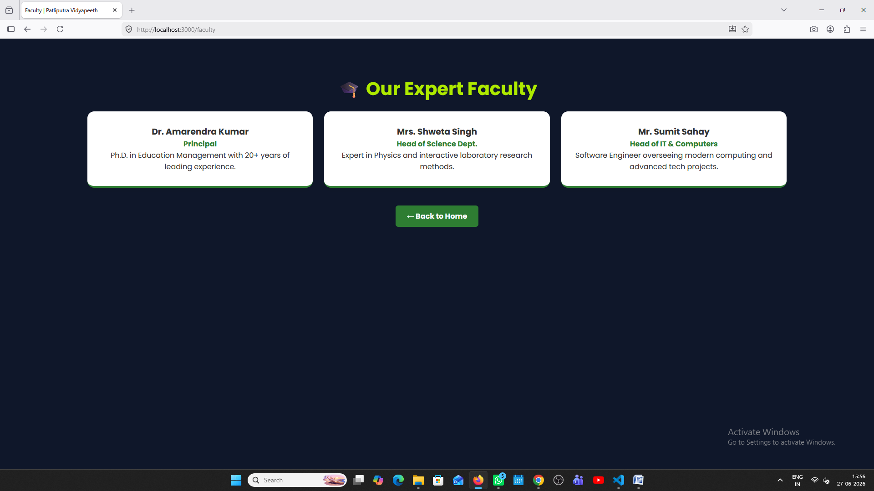
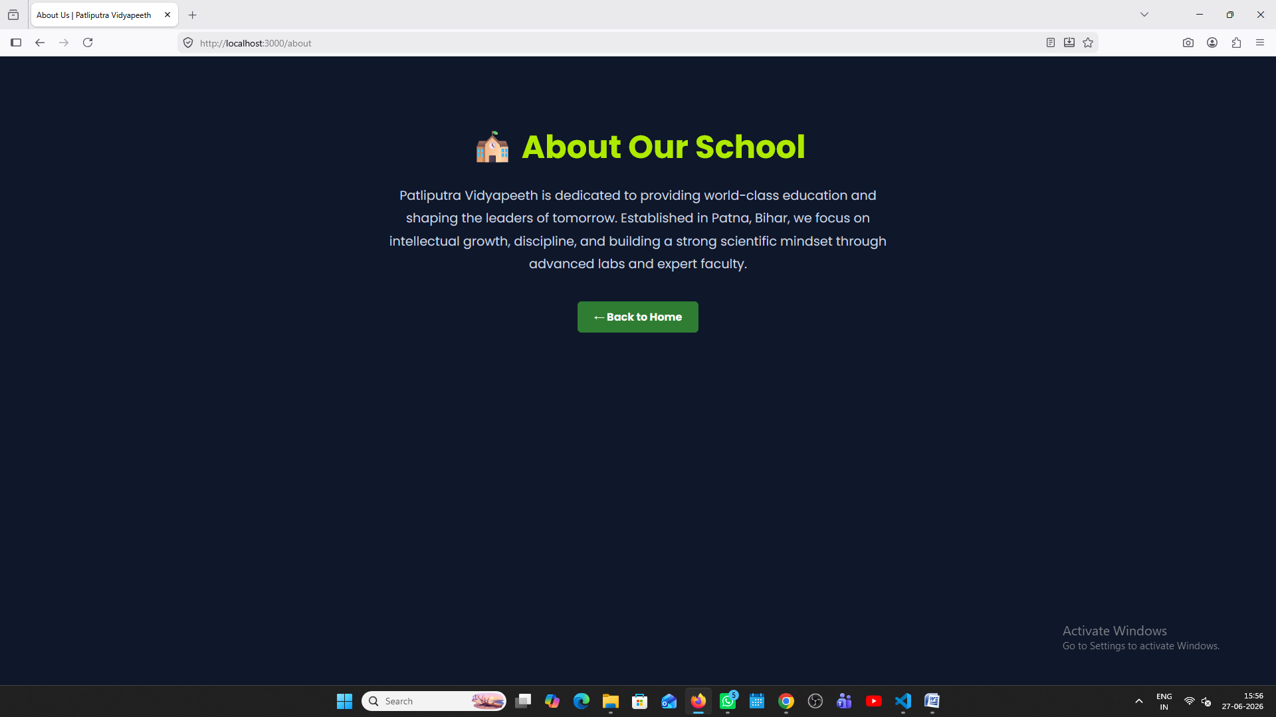
- Multi-Page Routing & Corporate Layout Branding: All primary informational links on the navigation bar (About Us, Faculty, Contacts, and Enquiry) are now fully operational. Additionally, the top navigation header has been refined to display the official school name alongside its CBSE Affiliation details and Registered Campus Address in a clean, elegant, and standard layout.
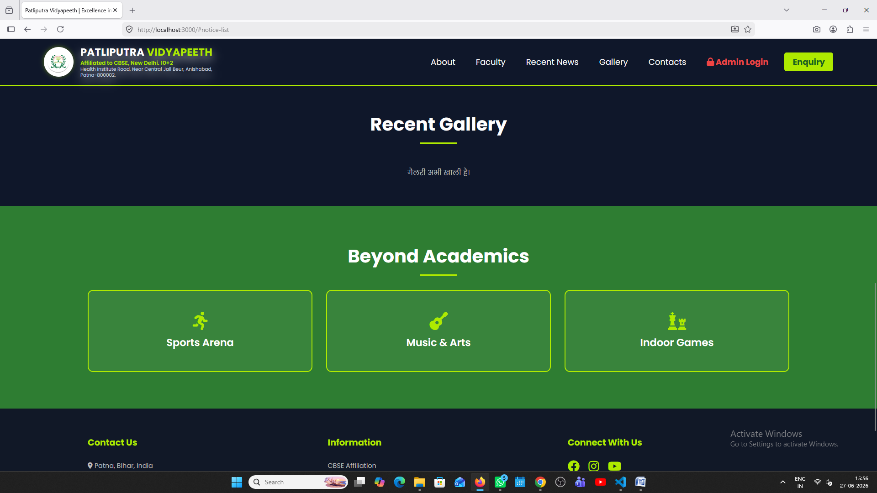
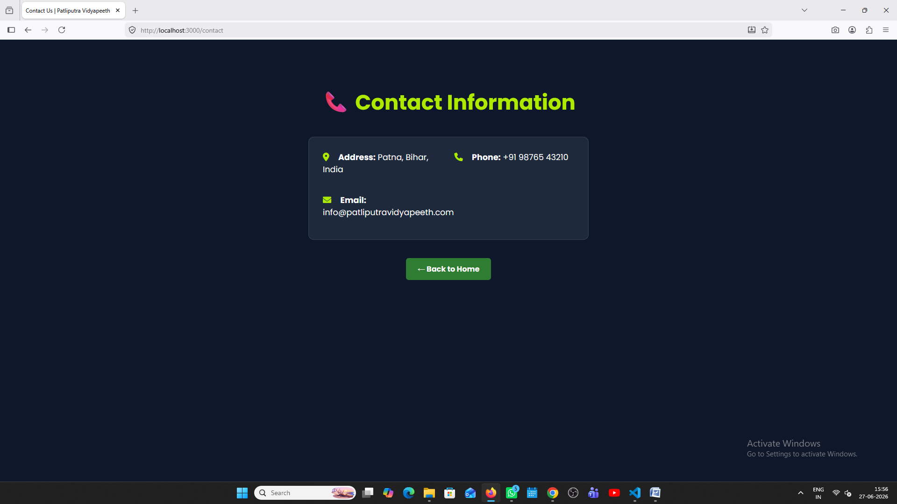

- Auto-Animated UI Elements: To give the portal a premium and modern feel, the logo image container features an integrated 5-second automatic 3D spinning loop and breathing glow effect. This feature triggers autonomously without requiring manual mouse hover interactions, enhancing visual engagement immediately upon loading.

Current Status & Next Steps
The portal is currently 100% customized, protected, and fully operational on our local deployment server (Port 3000). The interactive notice boards, multimedia photo gallery cards, and lab layout popup modals are functioning smoothly.

Report Prepared By: Sumit Sahay
Managed & Developed by Sumit Sahay

